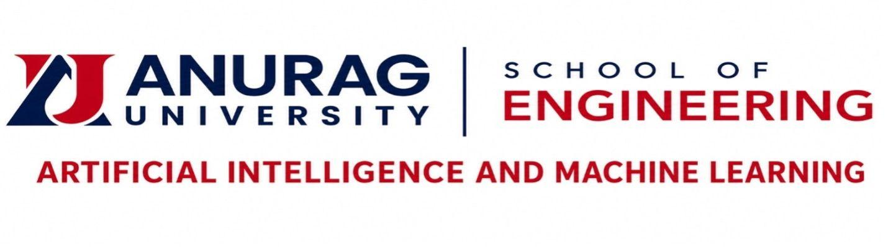

PROJECT DIARY

Echo: AI-Based Hazardous Sound Detection and Smart Emergency Guidance

Nikhilesh Garipally
23EG107E19

Dr. G. Ashok Kumar

2026-2027

